|  |  |  |
| --- | --- | --- |
| O*peration  Romania  Trust* |  | News Update **SEPTEMBER 2022** |

Showing God’s love to the people of Romania by supporting families in and around Oradea

Reg. charity No. 1053406 Registered address: 38 Meadow Way Littlehampton, West Sussex. BN17 6BL. United Kingdom

**T**

**he summer is over;** the Autumn beckons. The sun has shone and the much-needed rains have come. This is true of the UK but also true in Romania.

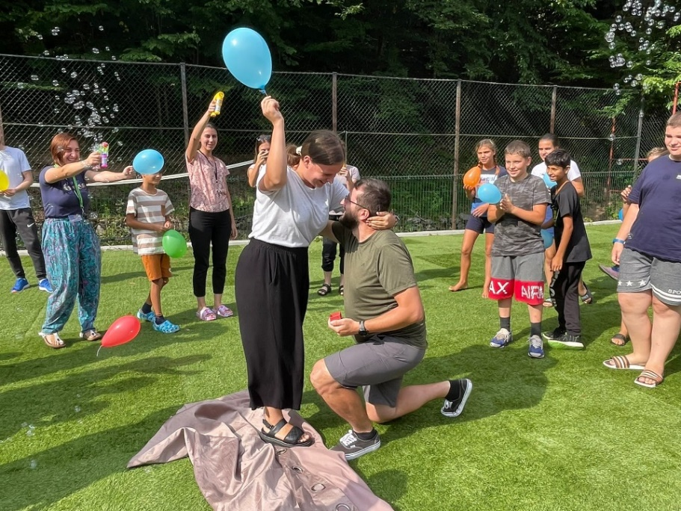

The Boga Camp had three action-packed weeks, one of which was rained on while the other two the sun shone.   
So many needy children and families have been reached this year. So many hungry mouths have been fed. So many happy children have gone home to share their stories with their families.  
We ask you to **pray** for the ongoing contacts with these families – that God will bless them and draw many of them into His ever-increasing family.

Two team members, for whom Boga will be forever etched in their minds and hearts, announced their engagement in a very dramatic way on the sports pitch, surrounded by happy children and other team members.

The proposal

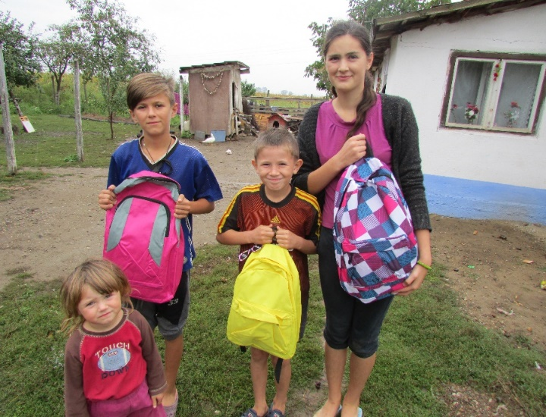

And then there is the **back-to-school** project. Many children will be able to go to school in confidence, with the right equipment to learn.

Please **pray** that their school experiences will be happy and successful.  
Thank you for your ongoing support.

**Roger Purdom**

**B**

**ack in June** we held our ORT Coffee Morning, having postponed it twice because of Covid. We had a good turn out to buy from the bookstall, the jams, marmalades, cakes and plants.  
We watched a moving portrayal of the work of the Emanuel Hospice in Oradea. (Check them out at <https://www.emanuelhospice.org/en> )

Thanks to the generosity of those who came + some legacy money which we had been given, we were able to send £6,765. Marinela, the Director of the Hospice, wrote to say **‘Thank you.’**

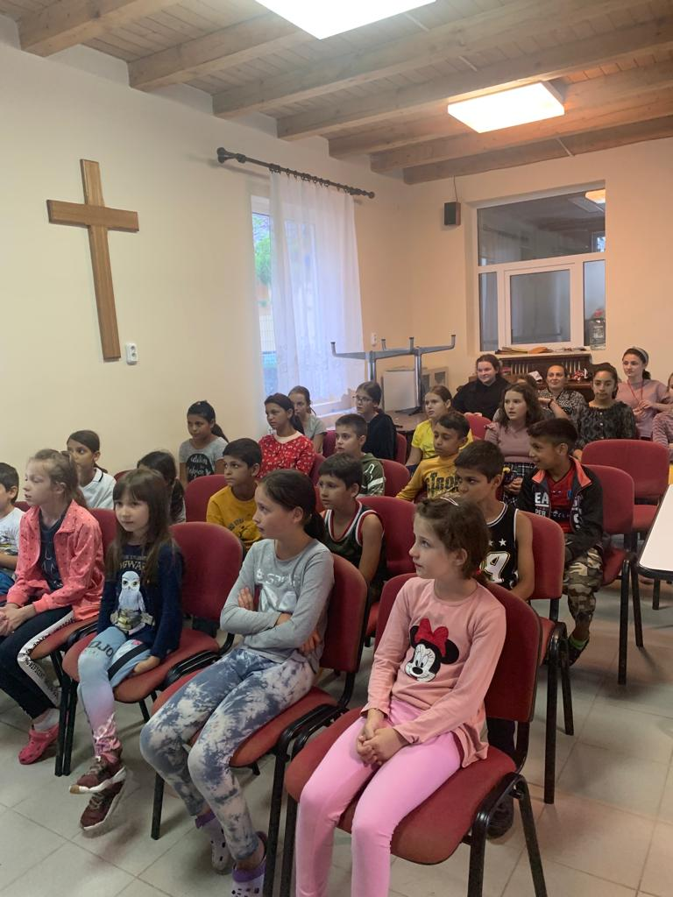

**B**

**ibles Headlice and Cake**

**Ani Foit shares her reflections on this year’s camp in the mountains:**

“By the grace of God, the three weeks of Boga camp have passed with all the challenges that came along.

The children arrived with great excitement, we were able to play outside and have nice trips in the woods.

In one occasion the whole group leaders and children decided to have a trip to the waterfall but a heavy rain came and we had to go with the cars to pick them up. They just had a lot of fun trying to get all 40 in 2 cars. We were very happy to see the children in all weeks enjoy their time in Boga even in these not-so-fortunate weather conditions

**One very nice story** from the first week was about a group of girls from the gypsy families. At the beginning they acted as against the rest of the group having arguments and throwing threats. Later they started to share the stories about their families and the problems they have at home. Two of them said that they would like to change their life and live how they learn in the camp but this is very difficult in their community.

Every evening, some of the leaders will spend time with them: talk about their concerns and pray together. They asked if they could have their own bibles and Nelu asked a book shop in Oradea if they can help us. God touched their hearts and we got about **30 Bibles for free.**

In the second week we had again all kind of situations. Some children arrived in the camp with **head lice**. So we had to start right away with a shower, and with the special shampoo, we were able to clean them.

But let’s finish this on a very positive note! Sebi, the leader, surprised his girlfriend and proposed to her in the camp during a game! She was very much surprised and her first reaction was to hit him! But she said yes!!!! And everybody was very happy! We celebrated with **cake!**

As you could read, this was another challenging year, the hard times were mixed with encouragements and blessings and we could rejoice at the end for the outcome. There were many people we could thank for their involvement: helpers, leaders, sponsors, and prayer people.

We recognize that without your love, help and support all these would not be possible. We are very grateful, and we can only hope and pray that God will repay you one day.

**Above all we thank God for everything.** MAY GOD BLESS YOU ALL!” Ani.

Thank you for your prayers and support.

You can **unsubscribe** from receiving the Prayer Update or any other information we might want to send to you by contacting our Chairman, Roger Purdom at [roger.purdom@btinternet.com](mailto:roger.purdom@btinternet.com)

*OPERATION ROMANIA TRUST Treasurer & Sponsorship Co-ordinator, Miss Margaret Wilkinson, 2 Knightscroft Avenue, Rustington, West Sussex BN16 2HN Phone: 01903 775927 Email:* [*mawatsea@outlook*](mailto:mawatsea@outlook)*.com*

*Trustees: Roger Purdom (Chair); Andrew Terrell; Margaret Wilkinson; David & Margaret Millidge; Colin Beckhurst; Keith Varney.*